Table of Contents

Committee Name (Arial Bold, pt 25, purple) 2

Introduction (Arial Bold, pt 15) 2

Committee Charge (Arial Bold, pt 12) 2

Department Headline (Arial Bold, pt 25, purple #4D1979)

Committee Charge (Arial Bold, pt 15)
Body copy is Times New Roman pt 12. Describe 3-5 highlights that the committee accomplished during the report period. Use full sentences in present tense.

RECOMMENDATION/ACTION ITEM:
- This should be a bullet point summary list on the front/first page of your report.
- Item 1:
- Item 2:

Committee Members (Arial Bold, pt 12)
List names

Business Meeting Minutes and Summary

Annual Report Submitted By
Reporting Period
Date Report Submitted

Chart Styles:
- Headline: Arial, size 25, black
- XY Axis: Arial, size 14, black
- Include Key
- Use standardized colors:
2019 = #00AAA6 (turquoise)
2020 = #A7322B (red)
2021 = #00607C (blue)
2022 = #CC6822 (orange)
2023 = #5B996B (light green)
2024 = #4D1979 (purple)

Table Styles:
- Text: Arial, size 10.5
- Header row: purple fill, white text
- Headers: bold
- Left column: left aligned
- All others: centered

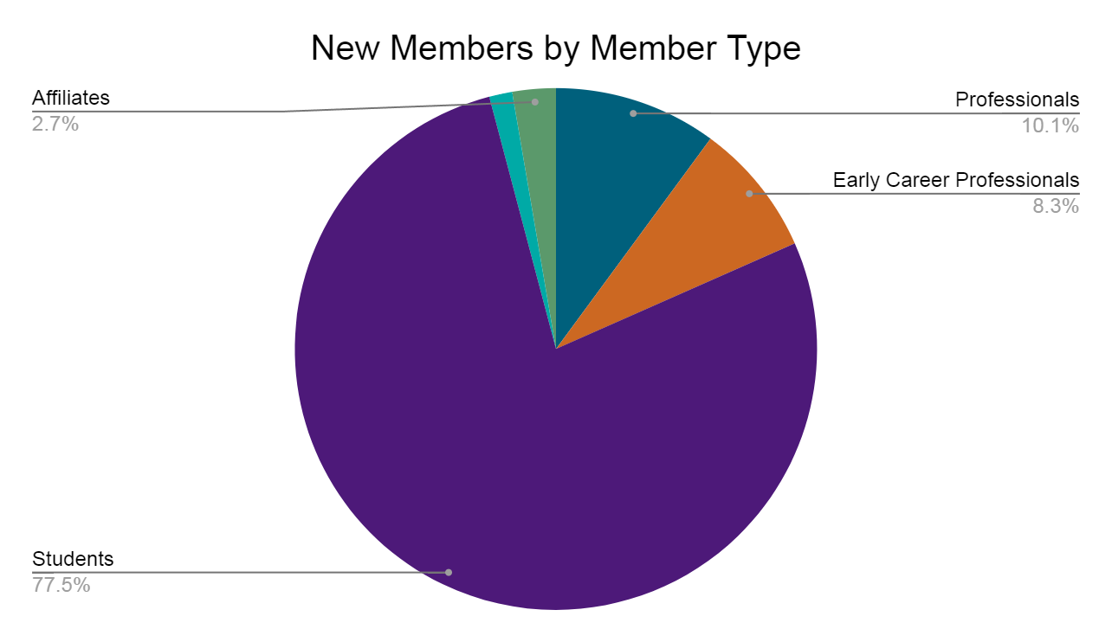

Date range* | 31 July–14 Sept.  2023 | 31 July–14 Sept.  2022 | 1 Sept. 2022–31 Aug. 2023
Total Pageviews** | 223,260 | 277,248 | 1,612,534
Home Pageviews | 26,668 | 18,801 | 147,915
Unique Site Users | 46,258 | 60,469 | 416,527

